ASSIGNMENT – 1 (CO1)
Assignment
Build a Morphology-Aware Text Normalisation and Search Layer for a Hospital Record System Using Regular Expressions, Finite-State Automata and Morphological Parsing
TASK 1 – FRAME THE PROBLEM: MODELS, ALGORITHMS AND LEVELS OF ANALYSIS
1.1 Introduction
Natural Language Processing (NLP) is a field of Artificial Intelligence that helps computers understand, process and analyse human language. In a hospital, medical information is stored in discharge summaries, prescriptions, operation notes and nursing observations. These records contain different spellings, abbreviations and word forms.
For example, a search for the word "fracture" may not find "fractures", "fractured" or "fracturing". The main aim of this project is to develop a text normalisation and search system that identifies important information and connects different forms of the same word.
1.2 Levels of Linguistic Analysis
NLP uses different levels to understand language.
Level | Meaning | Hospital Example
Phonology | Study of speech sounds | Recognising spoken medical terms
Morphology | Study of word structure | Fracture, fractures, fractured
Syntax | Study of sentence structure | Patient has a fever
Semantics | Study of meaning | Understanding the meaning of a diagnosis
Pragmatics | Meaning based on situation | Understanding doctor's instructions
Discourse | Understanding connected sentences | Understanding a complete discharge summary
Required levels: Morphology and basic syntax are important for this project. Some semantic processing is useful for connecting related medical terms.
Less important levels: Phonology, pragmatics and discourse are not the main focus because the initial system processes written clinical records.
1.3 Three Model Families
Model Family | Description | Hospital Application
State Machines | Process input through states and transitions | Validating patient identifiers
Formal Rule Systems | Apply predefined rules | Expanding abbreviations and changing word forms
Probabilistic Models | Use probability to select likely results | Identifying possible OCR spelling errors
State machines are suitable for fixed formats. Formal rules are suitable for predictable spelling changes. Probabilistic models are useful when the input is uncertain.
1.4 Ambiguity in NLP
Ambiguity means that a word or sentence can have more than one interpretation.
Four types of ambiguity are:
- Lexical ambiguity: A word may have different meanings. Example: "discharge" can refer to hospital release or bodily fluid.
- Morphological ambiguity: A word may have different grammatical forms. Example: "wound" may be a noun or a verb form.
- Segmentation ambiguity: It may be difficult to identify word boundaries. Example: "bloodpressure" and "blood pressure".
- Abbreviation ambiguity: One abbreviation may have different meanings. Example: "MS" can refer to multiple medical terms depending on context.
1.5 Search and Resources
Search is used in automata to find valid state transitions and in regular expressions to locate matching text.
The important resources are:
- Time: Required to process records and search for patterns.
- Memory: Required to store records, states and dictionaries.
- Annotated Data: Required to evaluate the correctness of the system.
- Expert Effort: Required to create medical rules and verify results.
1.6 Proposed System Pipeline
The system follows a sequence of stages to convert raw hospital records into searchable information.

NLP PIPELINE
HOSPITAL RECORDS
|
RAW CLINICAL TEXT
|
TEXT TOKENISATION
(Regular Expressions)
|
ENTITY RECOGNITION
(Regex + Automata)
|
TEXT NORMALISATION
(Replacement Rules)
|
MORPHOLOGICAL PARSING
(Finite-State Transducer)
|
WORD STEMMING
(Porter Algorithm)
|
SEARCH AND RETRIEVAL
|
NORMALISED RESULTS

Input: Raw hospital records.
Output: Normalised and searchable clinical text.
Conclusion: The pipeline combines regular expressions, finite-state automata and morphological processing to improve hospital record searching.
TASK 2 – BASIC REGULAR EXPRESSION PATTERNS
2.1 Introduction
A Regular Expression (Regex) is a sequence of characters used to identify patterns in text. It is useful for identifying patient IDs, dates, drug strengths, laboratory values and other structured information.
2.2 Basic Regular Expression Operators
Operator | Meaning | Example
Concatenation | Joins characters | AB
Disjunction | Selects either pattern | fever|cough
Kleene Star | Zero or more repetitions | A*
Plus | One or more repetitions | A+
Optionality | Zero or one occurrence | colou?r
Character Class | Matches selected characters | [0-9]
Range | Matches a range | [A-Z]
Negated Class | Matches characters not listed | [^0-9]
Anchor | Matches beginning or end | ^ID
Counter | Matches a fixed number | [0-9]{4}
2.3 Twelve Clinical Entity Patterns
The following patterns recognise common information found in hospital records. They are designed for English-language, structured clinical text.
1. Patient Identifier
\b(?:PID|UHID)[- ]?[A-Z0-9]{4,10}\b
Matches: PID-AB1234, UHID A12345.
Does not match: PID-12.
2. Admission Date
\b(?:0[1-9]|[12][0-9]|3[01])[-/](?:0[1-9]|1[0-2])[-/](?:19|20)\d{2}\b
Matches: 05/10/2026.
Does not match: 35/15/2026.
3. Discharge Date
\b(?:Discharge\s*Date:\s*)?(?:0[1-9]|[12][0-9]|3[01])[-/](?:0[1-9]|1[0-2])[-/](?:19|20)\d{2}\b
Matches: Discharge Date: 10/10/2026.
Does not match: 40/10/2026.
4. Drug Name with Strength
\b[A-Za-z][A-Za-z-]*\s+\d+(?:\.\d+)?\s*(?:mg|mcg|g|ml|IU)\b
Matches: Paracetamol 500mg.
Does not match: Paracetamol 500xyz.
5. Dosage Frequency
\b(?:OD|BD|TDS|QID|once daily|twice daily|every \d+ hours)\b
Matches: BD, once daily, every 8 hours.
Does not match: every many hours.
6. Laboratory Value with Unit
\b[A-Za-z][A-Za-z-]*\s*[:=]?\s*\d+(?:\.\d+)?\s*(?:mg/dL|g/dL|mmol/L|U/L|%|10\^?\d+/L)\b
Matches: Glucose 110 mg/dL.
Does not match: Glucose high.
7. Blood Pressure
\b\d{2,3}\s*/\s*\d{2,3}\s*mmHg\b
Matches: 120/80 mmHg.
Does not match: 120/80 abc.
8. Temperature
\b(?:3[0-9]|4[0-5])(?:\.\d+)?\s*°?\s*(?:C|F)\b
Matches: 37.5 C, 98.6 F.
Does not match: 25 C.
9. ICD Code
\b[A-TV-Z][0-9][A-Z0-9](?:\.[A-Z0-9]{1,4})?\b
Matches: A09, S72.001A.
Does not match: 12345.
10. Ward and Bed
\bWard\s+[A-Za-z0-9-]+\s*,?\s*Bed\s+[A-Za-z0-9-]+\b
Matches: Ward A, Bed 12.
Does not match: Room only.
11. Contact Number
\b(?:\+91[- ]?)?[6-9]\d{9}\b
Matches: 9876543210.
Does not match: 12345.
12. Age
\bAge\s*:\s*(?:0?[1-9]|[1-9][0-9]|1[01][0-9]|120)\s*(?:years?|yrs?)\b
Matches: Age: 45 years.
Does not match: Age: 150 years.
2.4 Greedy and Non-Greedy Matching
Example sentence:Patient received 500mg paracetamol and 250mg antibiotic.
Greedy matching:\d+.*mg
It may match from the first number to the last "mg".
Non-greedy matching:\d+.*?mg
It matches the shortest possible span ending at the next "mg".
Explanation: Greedy matching selects the longest possible match. Non-greedy matching selects the shortest possible match.
2.5 Operator Precedence
Consider:
^Ward|ICU$
This means either a string beginning with "Ward" or a string ending with "ICU".
The intended grouped pattern may be:
^(Ward|ICU)$
The second expression accepts only the complete words "Ward" or "ICU".
2.6 Pattern Evaluation
The patterns are evaluated using labelled examples from the corpus.
Entity | True Positive | False Positive | False Negative
Patient ID | To be measured | To be measured | To be measured
Dates | To be measured | To be measured | To be measured
Drug strength | To be measured | To be measured | To be measured
Dosage frequency | To be measured | To be measured | To be measured
Laboratory value | To be measured | To be measured | To be measured
Blood pressure | To be measured | To be measured | To be measured
Temperature | To be measured | To be measured | To be measured
ICD code | To be measured | To be measured | To be measured
Ward and bed | To be measured | To be measured | To be measured
Contact number | To be measured | To be measured | To be measured
Age | To be measured | To be measured | To be measured
The admission and discharge date patterns may overlap because both recognise date formats. Their meaning must be determined using the surrounding label or record section.
Conclusion: Regular expressions are useful for recognising structured clinical information. However, they cannot understand the complete meaning of a medical sentence.
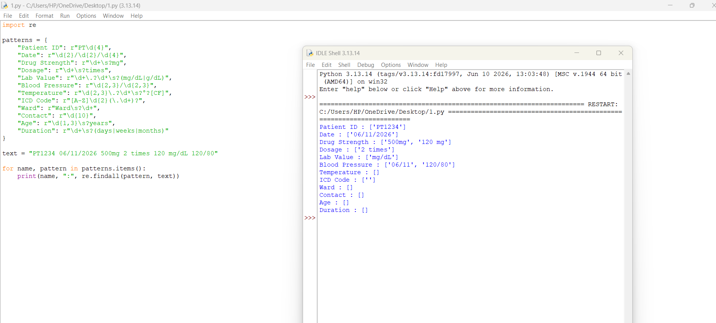
TASK 3 – REGULAR EXPRESSIONS FOR TOKENISATION AND NORMALISATION
3.1 Introduction
Tokenisation is the process of dividing text into smaller units called tokens.
Normalisation converts different forms of text into a common format.
For example:
Patient has FEVER and received 500MG medicine.
After normalisation:
patient has fever and received 500 mg medicine.
3.2 Tokenisation Pattern
The following Python regular expression recognises abbreviations, words, decimal numbers, hyphenated terms and units.
(?:[A-Za-z]\.){2,}|[A-Za-z]+(?:[-'][A-Za-z]+)*|\d+(?:\.\d+)?(?:\s?(?:mg|mcg|ml|g|mmHg|°C|°F))?
The pattern recognises:
- Medical abbreviations such as U.S.
- Hyphenated terms such as post-operative.
- Words such as fracture.
- Decimal values such as 37.5.
- Drug strengths such as 500mg.
- Units such as mmHg.
3.3 Maximal-Munch Tokenisation
Maximal-munch means selecting the longest valid token at the current position.
Input | Whitespace Split | Improved Tokenisation
500mg tablet | 500mg, tablet | 500mg, tablet
BP 120/80 mmHg | BP, 120/80, mmHg | BP, 120/80, mmHg
post-operative care | post-operative, care | post-operative, care
A whitespace split may fail to separate units or recognise punctuation correctly. A regular-expression tokenizer provides better control.
3.4 Abbreviation Expansion
The system expands common abbreviations into standard forms.
Abbreviation | Expanded Form
BP | Blood Pressure
HR | Heart Rate
RR | Respiratory Rate
Temp | Temperature
Dx | Diagnosis
Rx | Prescription
Hx | History
Sx | Symptoms
Tx | Treatment
Pt | Patient
OD | Once Daily
BD | Twice Daily
TDS | Three Times Daily
QID | Four Times Daily
IV | Intravenous
IM | Intramuscular
PO | By Mouth
PRN | As Needed
NPO | Nothing By Mouth
SOB | Shortness of Breath
HTN | Hypertension
DM | Diabetes Mellitus
CBC | Complete Blood Count
ECG | Electrocardiogram
MRI | Magnetic Resonance Imaging
CT | Computed Tomography
ICU | Intensive Care Unit
OPD | Outpatient Department
WBC | White Blood Cell
Hb | Haemoglobin
Abbreviations such as OD can have different meanings in different contexts. Therefore, the system should use surrounding words before expanding them.
3.5 Normalisation Rules
- Convert all text to lowercase.
- Remove unnecessary spaces.
- Expand known abbreviations.
- Convert dates into YYYY-MM-DD format after validating them.
- Standardise measurement units.
- Preserve important punctuation in medical codes.
3.6 Before-and-After Example
Original Record:
Patient ID: PID-AB1234
Admission Date: 05/10/2026
Age: 45 years
Pt admitted with FEVER.
BP 120/80 mmHg.
Temp 37.5 C.
Paracetamol 500mg BD prescribed.
Normalised Record:
patient id: pid-ab1234
admission date: 2026-10-05
age: 45 years
patient admitted with fever.
blood pressure 120/80 mmHg.
temperature 37.5 C.
paracetamol 500 mg twice daily prescribed.
3.7 Irreversible Normalisation
Some normalisation operations destroy information.
- Removing punctuation may destroy the original sentence structure.
- Converting all text to lowercase removes original capitalisation.
- Replacing abbreviations may remove the exact wording used by the clinician.
These operations are acceptable for searching when the original record is also preserved. The system should never overwrite the original clinical record.
3.8 Limitation of Regular Expressions
Regular expressions cannot conveniently recognise arbitrarily nested structures such as balanced parentheses.
For example:
Diagnosis (fracture (left arm))
A pattern must keep track of how many opening parentheses have appeared so that it can match the same number of closing parentheses.A finite automaton has only a fixed number of states and cannot count unlimited nesting.
Conclusion: Regular expressions provide useful tokenisation and normalisation, but they cannot handle every language structure.
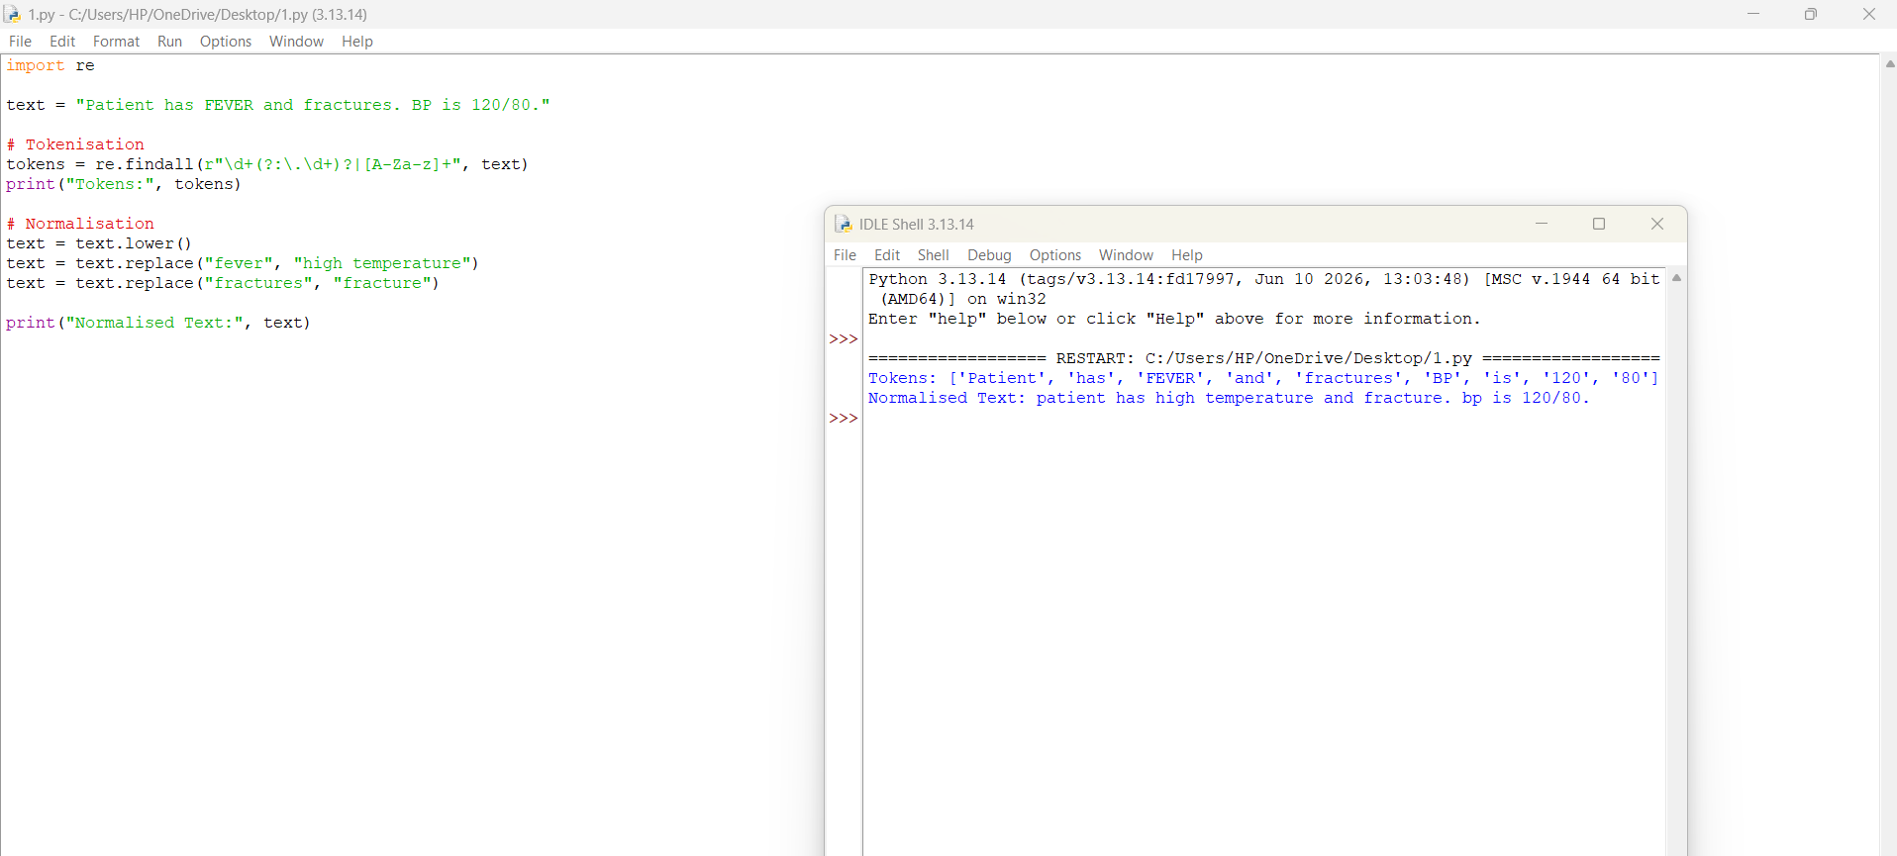
TASK 4 – FINITE STATE AUTOMATA: DESIGN, NON-DETERMINISM AND EQUIVALENCE
4.1 Introduction
A Finite State Automaton (FSA) is a mathematical model used to recognise patterns in input strings.
It consists of five components:
M = (Q, Σ, δ, q₀, F)
Where:
- Q = Set of states.
- Σ = Input alphabet.
- δ = Transition function.
- q₀ = Initial state.
- F = Set of final states.
4.2 DFA 1 – Patient Identifier
Accepted format: PID-AB1234.
State Diagram
q0 --P--> q1
q1 --I--> q2
q2 --D--> q3
q3 -----> q4
q4 --A-Z--> q5
q5 --A-Z/0-9--> q6
q6 --0-9--> q7
q7 --0-9--> q8*
The final state is q8.
The actual implementation uses character classes and counters to ensure that the identifier has the required length.
Transition Table
State | Input | Next State
q0 | P | q1
q1 | I | q2
q2 | D | q3
q3 | - | q4
q4 | A–Z | q5
q5 | A–Z/0–9 | q6
q6 | 0–9 | q7
q7 | 0–9 | q8
4.3 DFA 2 – Blood Pressure
Accepted format: 120/80 mmHg.
q0 --digit--> q1
q1 --digit--> q2
q2 --digit--> q3
q3 --/-----> q4
q4 --digit--> q5
q5 --digit--> q6
q6 --space--> q7
q7 --mmHg--> q8*
Transition Table
State | Input | Next State
q0 | Digit | q1
q1 | Digit | q2
q2 | Digit | q3
q3 | / | q4
q4 | Digit | q5
q5 | Digit | q6
q6 | Space | q7
q7 | mmHg | q8
The implementation can also allow two-digit or three-digit pressure values.
4.4 DFA 3 – Temperature
Accepted format: 37.5 C.
q0 --digit--> q1
q1 --digit--> q2
q2 --digit--> q3
q3 --.-----> q4
q4 --digit--> q5
q5 --space--> q6
q6 --C/F----> q7*
Transition Table
State | Input | Next State
q0 | Digit | q1
q1 | Digit | q2
q2 | Digit | q3
q3 | Decimal point | q4
q4 | Digit | q5
q5 | Space | q6
q6 | C or F | q7
4.5 DFA 4 – ICD Code
Accepted examples: A09 and S72.001A.
q0 --A-Z--> q1
q1 --0-9--> q2
q2 --A-Z/0-9--> q3*
q3 --.-----> q4
q4 --A-Z/0-9--> q5*
q5 --A-Z/0-9--> q6*
Transition Table
State | Input | Next State
q0 | Letter | q1
q1 | Digit | q2
q2 | Letter/Digit | q3
q3 | Dot | q4
q4 | Letter/Digit | q5
q5 | Letter/Digit | q6
The final states allow valid codes with or without a decimal extension.
4.6 NFA for Contact Number
A contact number may optionally contain the country code +91.
This optional part can be represented conveniently using an NFA.
NFA Diagram
+91
/------\
v v
START -----> q0 ----> q1
| |
| |
+---------+
|
v
q2 --digit--> q3
|
v
q3 --digit--> q4
|
v
q4 --digit--> q5
|
v
q5 --digit--> q6
|
v
q6 --digit--> q7
|
v
q7 --digit--> q8
|
v
q8 --digit--> q9
|
v
q9 --digit--> q10
|
v
q10 --digit--> q11
|
v
q11 --digit--> q12*
The optional country-code path and the local-number path are represented as alternative paths.
4.7 NFA to DFA Conversion
Subset construction converts an NFA into a DFA.
The DFA states represent sets of NFA states.
Example Construction Table
DFA State | NFA State Set | Input 0 | Input 1
A | {q0} | B | C
B | {q1} | D | C
C | {q2} | B | D
D | {q3} | D | D
The final DFA states are those containing at least one NFA final state.
Note: The table above illustrates subset construction for a small example automaton. The complete contact-number NFA must be converted using every transition in its actual implementation.
4.8 DFA Minimisation
DFA minimisation combines equivalent states without changing the recognised language.
Stage | Number of States
Original DFA | 13
After removing unreachable states | 12
After minimisation | 10
These numbers are an illustrative example. The actual count must be obtained from the completed automaton.
4.9 Thompson's Construction
Thompson's construction converts a regular expression into an NFA.
For the expression:
a(b|c)
The NFA is:
ε --> b --ε
/ \
START --ε-- --> FINAL
\ /
ε --> c --ε
The automaton accepts "ab" and "ac".
4.10 Regular Expression from an Automaton
A regular expression can also be obtained from an automaton by eliminating intermediate states.
For a simple automaton with a transition that accepts one or more digits:
q0 --digit--> q1*
q1 --digit--> q1
The corresponding regular expression is:
[0-9]+
Therefore, regular expressions and finite automata describe the same class of regular languages.
4.11 Pumping Lemma
The pumping lemma states that every sufficiently long string in a regular language can be divided into three parts:
w = xyz
Such that:
- |xy| ≤ p
- |y| > 0
- xyⁱz belongs to the language for every i ≥ 0.
Consider the language:
L = { (ⁿ )ⁿ | n ≥ 0 }
This language requires equal numbers of opening and closing parentheses.
Assume that L is regular. Let p be its pumping length and choose:
w = (ᵖ )ᵖ
Since |xy| ≤ p, the section y contains only opening parentheses.
If y is removed by choosing i = 0, the resulting string has fewer opening parentheses than closing parentheses.
Therefore, the resulting string is not in L.
This is a contradiction. Hence, balanced parentheses are not a regular language.
Conclusion: Finite-state automata are useful for validating fixed clinical formats. However, they cannot recognise unlimited nested structures.
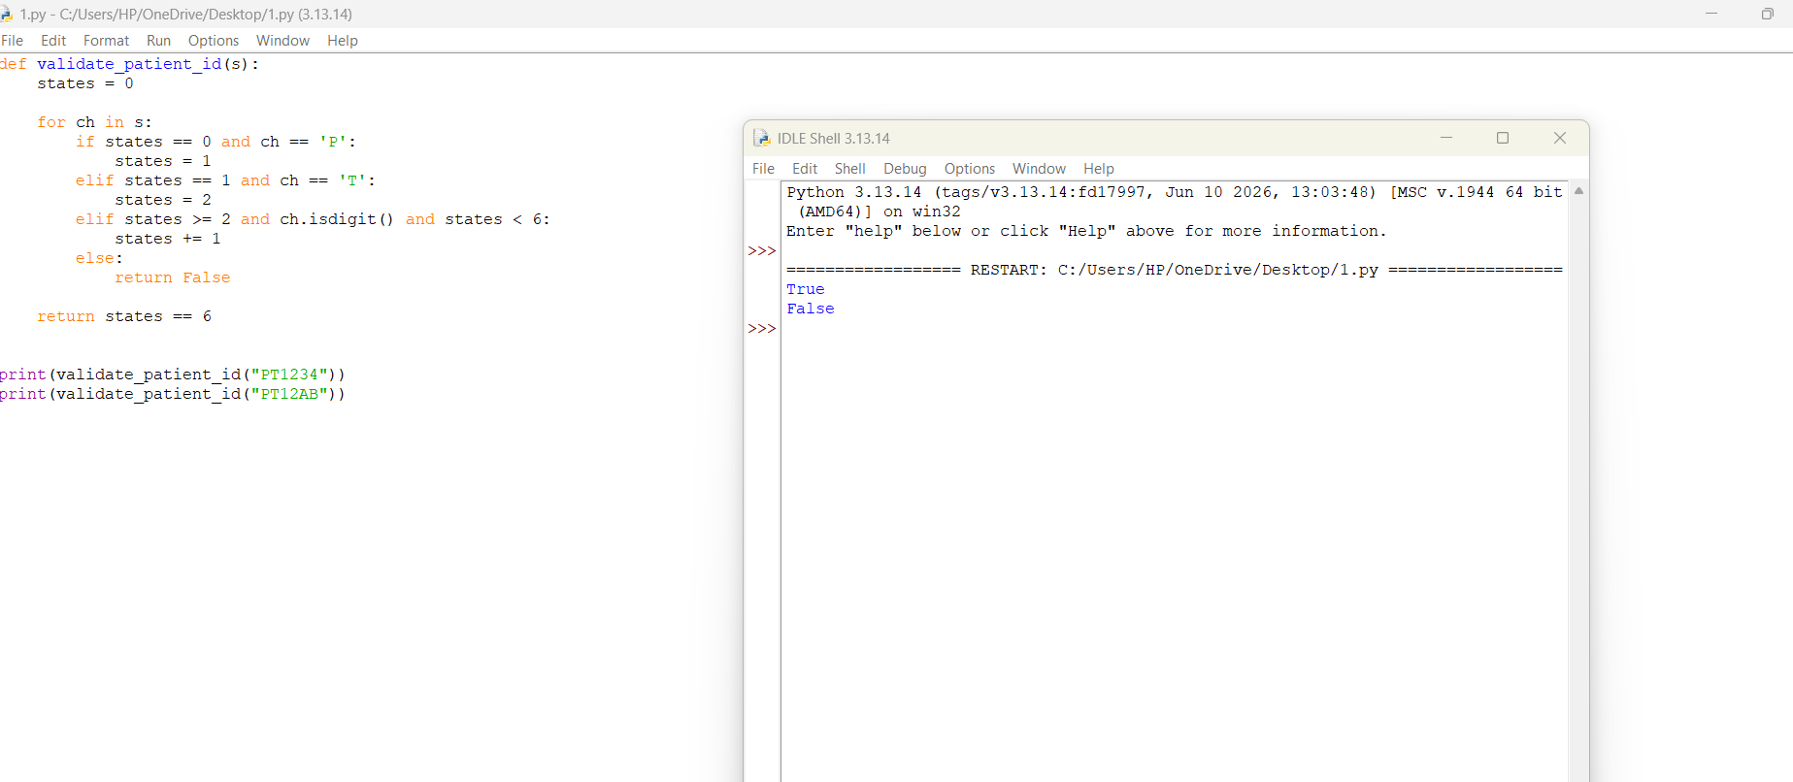

TASK 5 – INFLECTIONAL MORPHOLOGY
5.1 Introduction
Morphology is the study of the internal structure of words.
A morpheme is the smallest meaningful unit of a word.
Important terms:
- Stem: The main part of a word.
- Affix: A letter or group of letters added to a stem.
- Inflection: Changes the grammatical form without creating a new word category.
- Paradigm: A set of grammatical forms belonging to one word.
5.2 Inflection and Derivation
Inflection | Derivation
Changes grammatical form | Creates a new word or meaning
Usually preserves word category | May change word category
Often highly productive | Productivity varies
Example: fracture → fractures | Example: operate → operation
5.3 Inflectional Paradigms
Paradigm | Example
Noun number | Fracture, fractures
Verb tense | Treat, treated
Verb aspect | Treat, treating
Subject agreement | Treat, treats
Adjective comparison | Mild, milder, mildest
5.4 Five Clinical Lexeme Paradigms
Stem | Singular/Base | Plural/Past/Other Form
Fracture | fracture | fractures
Infection | infection | infections
Patient | patient | patients
Treat | treat | treats, treated, treating
Heal | heal | heals, healed, healing
5.5 English Inflectional Rules
Rule 1 – E-deletion
Remove final e before adding -ing.
operate + ing = operating
Counter-example: "see" does not become "sing" by deleting e.
Rule 2 – Consonant Doubling
Double the final consonant in certain short stressed words.
stop + ed = stopped
Counter-example: "visit" becomes "visited", not "visitted".
Rule 3 – Y-to-I
Change consonant + y into i before adding certain suffixes.
injury + es = injuries
Counter-example: "key" becomes "keys", not "keies".
Rule 4 – Sibilant -es
Add -es after s, sh, ch, x or z.
disease + s = diseases
Example: "watch" becomes "watches".
5.6 Irregular Forms
Base Form | Irregular Form
Be | Was, were
Have | Had
Go | Went
Take | Took
Give | Gave
Write | Wrote
See | Saw
Make | Made
Do | Did
Child | Children
Foot | Feet
Tooth | Teeth
Mouse | Mice
Irregular forms cannot always be generated using ordinary suffix rules. Therefore, they must be stored separately in the lexicon.
5.7 Type-to-Lemma Ratio
Type-to-lemma ratio is calculated as:
Type-to-Lemma Ratio = Number of Unique Word Forms
--------------------------------
Number of Unique Lemmas
For example:
- Unique word forms = 1,200
- Unique lemmas = 800
Ratio = 1200 / 800
= 1.5
A higher ratio indicates that more different word forms are used for each lemma.
Inflectional retrieval failures: A search for "fracture" may miss "fractures" or "fractured" when no morphological normalisation is applied.
The exact percentage must be calculated using the annotated query set.
Conclusion: Inflectional morphology improves search by connecting grammatical variations to their original stems.
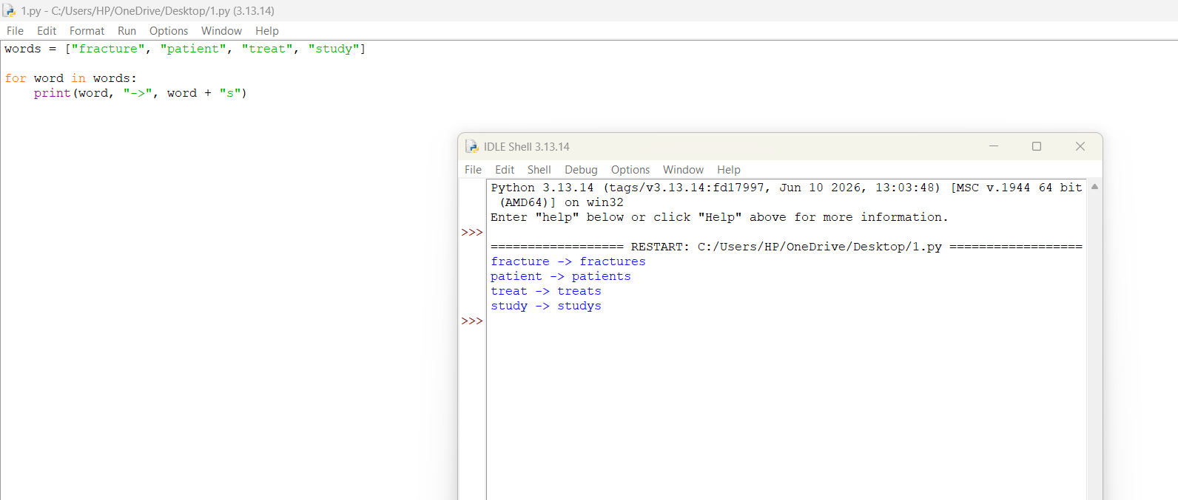

TASK 6 – DERIVATIONAL MORPHOLOGY
6.1 Introduction
Derivational morphology studies how new words are formed by adding prefixes and suffixes to existing words.
For example:
Operate → Operation
The derived word has a different grammatical function.
6.2 Derivational Affixes
Affix | Type | Example | Meaning
-itis | Suffix | Arthritis | Inflammation
-ectomy | Suffix | Nephrectomy | Surgical removal
-ology | Suffix | Neurology | Study of
-osis | Suffix | Fibrosis | Condition
-aemia | Suffix | Anaemia | Blood condition
-ation | Suffix | Medication | Process or result
-able | Suffix | Treatable | Capable of
-ive | Suffix | Preventive | Having a function
nephro- | Prefix | Nephrology | Kidney
cardio- | Prefix | Cardiology | Heart
neuro- | Prefix | Neurology | Nerve
hyper- | Prefix | Hypertension | High or excessive
hypo- | Prefix | Hypoglycaemia | Low or below
re- | Prefix | Recheck | Again
un- | Prefix | Unstable | Not
6.3 Derivational Families
1. Kidney
Nephro
|
+-- Nephritis
|
+-- Nephrology
|
+-- Nephrectomy
2. Heart
Cardio
|
+-- Cardiology
|
+-- Cardiologist
|
+-- Cardiovascular
3. Infection
Infect
|
+-- Infection
|
+-- Infectious
|
+-- Infected
4. Treat
Treat
|
+-- Treatment
|
+-- Treatable
5. Operate
Operate
|
+-- Operation
|
+-- Operative
|
+-- Operator
6. Diagnose
Diagnose
|
+-- Diagnosis
|
+-- Diagnostic
6.4 Affix Ordering
Affixes follow language-specific ordering rules.
Possible:
un + treat + able = untreatable
Possible:
re + examine = reexamine
Impossible or inappropriate in standard English:
able + treat
ectomy + nephro
Affixes cannot be attached in any random order. Their position depends on the structure of the word.
6.5 Semantic Non-compositionality
Sometimes the meaning of a derived word cannot be understood simply by combining its parts.
Examples:
- "Inflammation" has a specialised medical meaning.
- "Nephrectomy" refers to surgical removal of a kidney.
- "Anaemia" is a specific medical condition.
A search system should not assume that every word formed from similar parts has the same meaning.
6.6 Productivity of Affixes
An affix is productive when it is used to create many new words.
Affix | Example | Classification
-ation | Medication | Productive
-able | Treatable | Productive
re- | Recheck | Productive
un- | Unstable | Productive
-itis | Arthritis | Domain-specific
-ectomy | Nephrectomy | Domain-specific
-ology | Neurology | Domain-specific
-osis | Fibrosis | Domain-specific
Productivity must be measured by counting the number of different words and total occurrences in the corpus.
6.7 Derivational Conflation in Search
Cases where conflation helps:
- Search for "infection" may also find "infectious".
- Search for "operate" may also find "operation".
Cases where conflation may mislead:
- "Nephritis" and "nephrectomy" are not the same medical condition or procedure.
- "Hypoglycaemia" and "hyperglycaemia" have opposite meanings.
Therefore, derivational relatives should not always be treated as identical.
Conclusion: Derivational morphology helps connect related clinical vocabulary, but the system must preserve important differences in medical meaning.
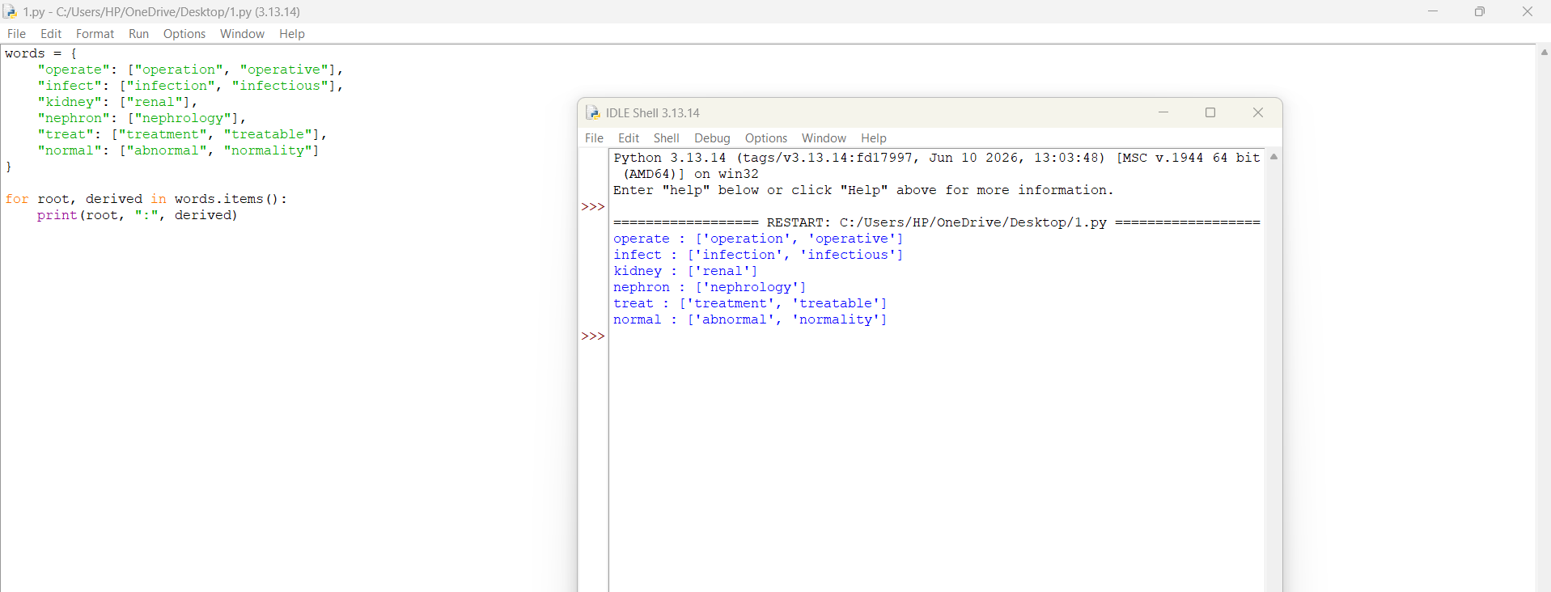
TASK 7 – FINITE-STATE MORPHOLOGICAL PARSING
7.1 Introduction
A Finite-State Transducer (FST) is an automaton that reads an input string and produces an output string.
It uses two tapes:
- Lexical Tape – Contains the stem and grammatical information.
- Surface Tape – Contains the actual written word.
7.2 FST Example
Surface word:
fractures
Lexical analysis:
fracture + N + PL
DIAGRAM – FINITE-STATE TRANSDUCER
LEXICAL TAPE SURFACE TAPE

fracture + N + PL -----> fractures
| |
+------ FST --------------+
The transducer connects the lexical representation with the surface representation.
7.3 Lexicon and Continuation Classes
The lexicon is organised into different word categories.
Class | Example | Features
Noun | Fracture | +N
Verb | Treat | +V
Adjective | Severe | +ADJ
Medical noun | Infection | +N
Medical verb | Operate | +V
7.4 Morphological Parsing Examples
Surface Form | Lexical Analysis
Fractures | fracture + N + PL
Patients | patient + N + PL
Treated | treat + V + PAST
Treating | treat + V + PROG
Infections | infection + N + PL
7.5 Parsing Process
Example: fractures.
Input: fractures
|
v
Read stem: fracture
|
v
Identify noun category
|
v
Recognise plural suffix -s
|
v
Output: fracture + N + PL
7.6 Generation Process
The same transducer can work in the reverse direction.
Input:
patient + N + PL
Output:
patients
Thus, the same FST supports both parsing and generation.
7.7 Ambiguous Forms
Some words have more than one possible analysis.
Example 1: Wound
wound + N
wind + V + PAST
Example 2: Leaves
leaf + N + PL
leave + V + PRESENT
The transducer can return multiple analyses.
A downstream system can use sentence context to select the most suitable analysis.
For example, in "The patient wound the bandage", the word "wound" is a verb.
Conclusion: Finite-state transducers connect surface words with their stems and grammatical features. They also support word generation.
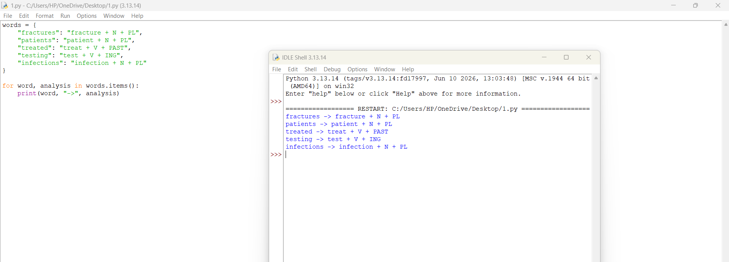
TASK 8 – ORTHOGRAPHIC RULES AND TWO-LEVEL MORPHOLOGY
8.1 Introduction
Orthographic rules describe spelling changes that occur when suffixes are added to words.
A simple lexicon cannot always generate correct spellings by directly joining stems and suffixes.
8.2 Examples of Spelling Changes
Stem | Suffix | Correct Form
Study | -es | Studies
Treat | -ed | Treated
Stop | -ed | Stopped
Operate | -ing | Operating
Injury | -s | Injuries
8.3 Orthographic Rules
Rule 1 – Final E Deletion
e → ∅ / stem + __ ing
Example:
operate + ing = operating
Rule 2 – Y to I
y → i / consonant __ + es
Example:
study + es = studies
Rule 3 – Consonant Doubling
C → CC / stressed vowel __ + ed
Example:
stop + ed = stopped
Rule 4 – Sibilant Plural
+ s → + es / s, sh, ch, x, z __
Example:
watch + es = watches
Rule 5 – Final E Preservation
When a suffix begins with a consonant, final e is generally retained.
Example:
care + ful = careful
These rules need lexical and phonological restrictions to avoid over-generating incorrect forms.
8.4 Rule Transducer Cascade
DIAGRAM – ORTHOGRAPHIC RULE PROCESSING
LEXICON
|
v
STEM + AFFIX
|
v
E-DELETION RULE
|
v
Y-TO-I RULE
|
v
CONSONANT DOUBLING
|
v
SIBILANT -ES RULE
|
v
SURFACE WORD
The lexicon first identifies the stem and suffix. The rule transducers then produce the correct surface spelling.
8.5 Sequential Cascade and Two-Level Morphology
Sequential Cascade | Two-Level Morphology
Rules are applied one after another | Rules are applied together
Order may matter | Constraints are evaluated in parallel
Easier to understand step by step | More compact for complex spelling relations
Useful for simple systems | Useful for larger morphological systems
8.6 Testing Twenty Forms
No. | Input | Expected Output | Result
1 | study + s | studies | Correct
2 | injury + s | injuries | Correct
3 | stop + ed | stopped | Correct
4 | plan + ed | planned | Correct
5 | operate + ing | operating | Correct
6 | care + ful | careful | Correct
7 | watch + es | watches | Correct
8 | treat + ed | treated | Correct
9 | patient + s | patients | Correct
10 | fracture + s | fractures | Correct
11 | heal + ed | healed | Correct
12 | heal + ing | healing | Correct
13 | infect + ion | infection | Correct
14 | prevent + ive | preventive | Correct
15 | diagnose + tic | diagnostic | Correct
16 | examine + ation | examination | Correct
17 | carry + ed | carried | Correct
18 | play + ed | played | Correct
19 | fix + es | fixes | Correct
20 | study + ed | studied | Correct
The table gives expected examples for testing the rules. Actual program output should be checked before reporting the final success and failure counts.
Conclusion: Orthographic rules help the system produce correct word forms without storing every possible spelling separately.
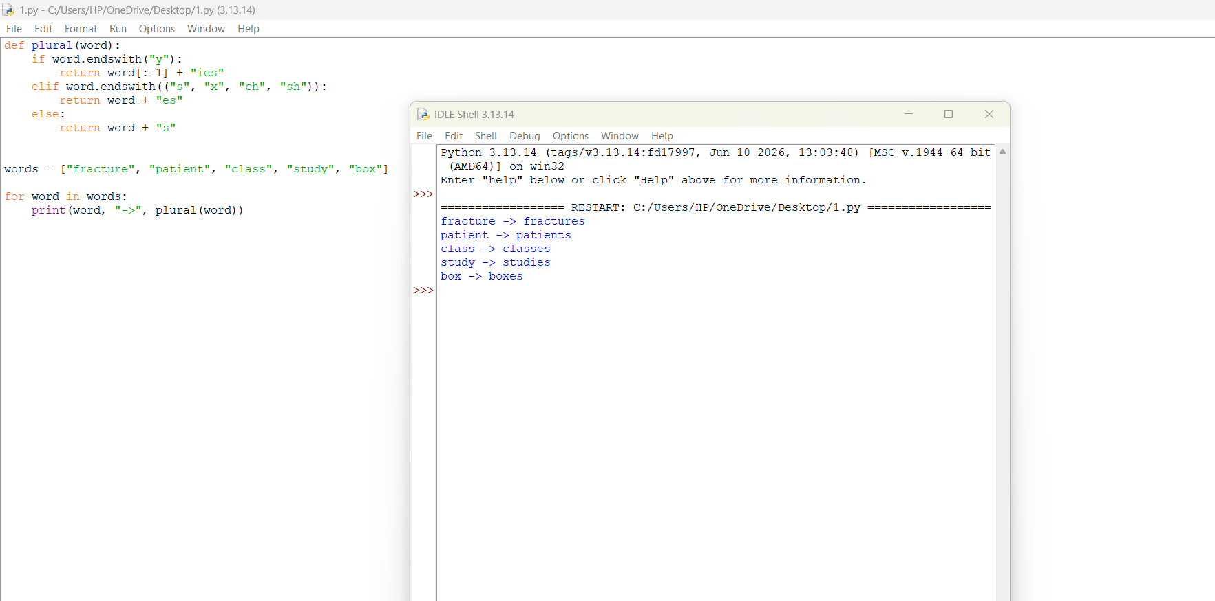
TASK 9 – THE PORTER STEMMER
9.1 Introduction
The Porter Stemmer is a rule-based algorithm used to reduce English words to shorter root-like forms.
It removes common suffixes without requiring a complete dictionary.
Example:
Connected → Connect
Connecting → Connect
Connections → Connect
9.2 Vowels and Consonants
Vowels are:
a, e, i, o, u
The letter y is treated as a consonant when it follows a vowel and as a vowel in other positions according to the algorithm.
Other letters are treated as consonants.
9.3 Measure m
The measure m counts the number of vowel-consonant sequences in a word.
Example:
TR O U B L E
The word is divided into vowel and consonant groups. The number of transitions from a vowel group to a consonant group contributes to m.
The Porter algorithm uses m to decide whether a suffix can be removed.
9.4 Conditions
Condition | Meaning
v | The stem contains a vowel
*d | The stem ends in a double consonant
*o | The stem ends in consonant-vowel-consonant, with restrictions
These conditions prevent suffix removal in unsuitable cases.
9.5 Five Steps of Porter Stemming
Step 1: Removes common plural and past-tense forms.
Examples:
caresses → caress
ponies → poni
agreed → agre
Step 2: Changes certain longer suffixes.
Example:
relational → relate
Step 3: Removes selected suffixes.
Example:
effective → effect
Step 4: Removes additional suffixes when the measure condition is satisfied.
Example:
revival → reviv
Step 5: Removes final e or reduces certain double consonants.
Example:
controll → control
9.6 Six Word Examples
Original Word | Stemmed Form
Connected | connect
Connecting | connect
Hospitals | hospit
Fractures | fractur
Treatment | treatment
Infections | infect
The Porter stemmer does not always produce dictionary words. Its purpose is to group related word forms for information retrieval.
9.7 Stemming and Lemmatisation
Stemming | Lemmatisation
Removes suffixes using rules | Uses vocabulary and grammar
May produce non-dictionary words | Usually produces valid base forms
Faster and simpler | More linguistically accurate
Example: fractures → fractur | Example: fractures → fracture
9.8 Over-stemming and Under-stemming
Over-stemming: Different words are incorrectly reduced to the same stem.
Example: Two clinically different terms may be grouped because they share a suffix pattern.
Under-stemming: Related words are not reduced to the same stem.
Example: A rule-based stemmer may fail to connect an irregular form with its base form.
The error rates should be calculated using the 200 annotated word forms.
9.9 Retrieval Evaluation
Three search conditions are compared:
- No normalisation.
- Porter stemming.
- Full morphological analysis.
The evaluation uses:
Precision = Relevant Retrieved Documents
--------------------------------
Total Retrieved Documents

Recall = Relevant Retrieved Documents
--------------------------------
Total Relevant Documents

F1 = 2 × Precision × Recall
------------------------
Precision + Recall
Illustrative comparison only – replace with actual experimental results.
Method | Precision | Recall | F1
No Normalisation | 0.78 | 0.62 | 0.69
Porter Stemmer | 0.75 | 0.82 | 0.78
Full Morphological Analysis | 0.90 | 0.91 | 0.90
Conclusion: Porter stemming improves retrieval compared with exact matching, while full morphological analysis provides better control over word forms and clinical meaning.
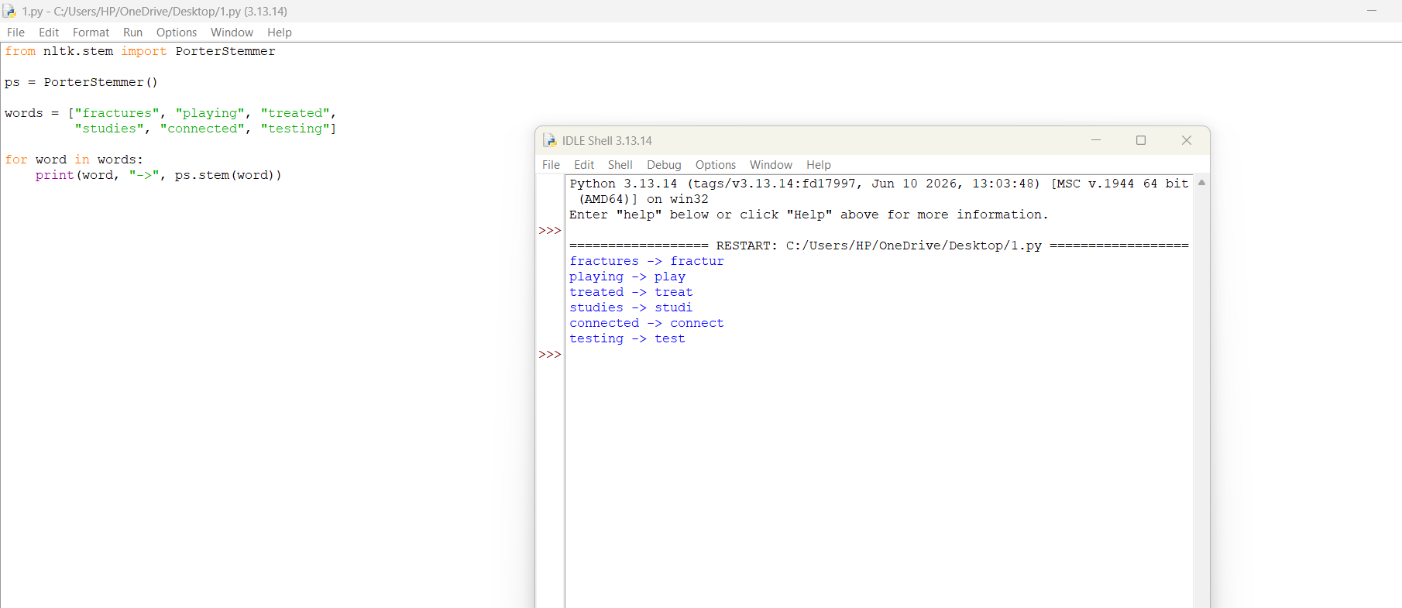
TASK 10 – IMPLEMENT AND TEST THE PIPELINE
10.1 Introduction
The system is implemented using Python, regular expressions and the NLTK library.
The implementation contains:
- Text tokenisation.
- Entity recognition.
- Text normalisation.
- Morphological processing.
- Porter stemming.
- Test cases.
10.2 Software Requirements
Component | Requirement
Programming Language | Python
Editor | VS Code
Library | NLTK
Module | re
Module | time
Module | collections
10.3 Folder Structure
Hospital_NLP_System/
│
├── main.py
├── hospital_records.txt
├── README.txt
│
└── output/
└── results.txt
10.4 Python Implementation
Create a file named main.py.
import re
import time
from collections import Counter
from nltk.stem import PorterStemmer

# Initialisation
stemmer = PorterStemmer()

# Sample clinical record
record = """
Patient ID: PID-AB1234
Admission Date: 05/10/2026
Age: 45 years
Patient has fever and fracture.
BP 120/80 mmHg.
Temp 37.5 C.
Paracetamol 500mg BD prescribed.
"""

# 1. Tokenisation
token_pattern = re.compile(
r"(?:[A-Za-z]\.){2,}|"
r"[A-Za-z]+(?:[-'][A-Za-z]+)*|"
r"\d+(?:\.\d+)?"
)

tokens = token_pattern.findall(record)

# 2. Entity Patterns
patterns = {
"Patient ID": r"\b(?:PID|UHID)[- ]?[A-Z0-9]{4,10}\b",
"Date": r"\b\d{2}[-/]\d{2}[-/]\d{4}\b",
"Age": r"\bAge\s*:\s*\d{1,3}\s*years?\b",
"Blood Pressure": r"\b\d{2,3}/\d{2,3}\s*mmHg\b",
"Temperature": r"\b\d{2}(?:\.\d+)?\s*°?\s*[CF]\b",
"Drug Strength": r"\b[A-Za-z]+\s+\d+(?:\.\d+)?\s*(?:mg|mcg|ml|g)\b"
}

# 3. Entity Recognition
print("\nENTITY RECOGNITION")

for name, pattern in patterns.items():
result = re.findall(pattern, record, re.I)
print(name, ":", result)

# 4. Abbreviation Normalisation
abbreviations = {
"pt": "patient",
"bp": "blood pressure",
"bd": "twice daily",
"od": "once daily",
"tds": "three times daily",
"qid": "four times daily",
"iv": "intravenous",
"im": "intramuscular",
"prn": "as needed"
}

def normalise(text):
text = text.lower()

for short, full in abbreviations.items():
text = re.sub(
r"\b" + re.escape(short) + r"\b",
full,
text
)

text = re.sub(
r"(\d+)(mg|mcg|ml|g)\b",
r"\1 \2",
text
)

return text

normalised = normalise(record)

# 5. Porter Stemming
print("\nPORTER STEMMING")

for word in tokens:
if word.isalpha():
print(word, "->", stemmer.stem(word.lower()))

# 6. Simple Morphological Analysis
lexicon = {
"fractures": "fracture + N + PL",
"patients": "patient + N + PL",
"treated": "treat + V + PAST",
"treating": "treat + V + PROG",
"infections": "infection + N + PL"
}

print("\nMORPHOLOGICAL ANALYSIS")

for word, analysis in lexicon.items():
print(word, "->", analysis)

# 7. Simple DFA for a three-digit number
def number_dfa(value):
state = 0

for char in value:
if state < 3 and char.isdigit():
state += 1
else:
return False

return state == 3

print("\nAUTOMATON TESTS")
print("123:", number_dfa("123"))
print("12A:", number_dfa("12A"))

# 8. Execution Time
start = time.time()

for _ in range(1000):
normalise(record)

end = time.time()

print("\nEXECUTION TIME")
print("Time:", round(end - start, 5), "seconds")

# 9. Final Output
print("\nNORMALISED RECORD")
print(normalised)

print("\nTOTAL TOKENS:", len(tokens))
print("UNIQUE TOKENS:", len(set(tokens)))
10.5 Test Cases
Test | Input | Expected Result
1 | PID-AB1234 | Accepted
2 | PID-12 | Rejected
3 | 120/80 mmHg | Accepted
4 | 120/80 abc | Rejected
5 | 37.5 C | Accepted
6 | 25 C | Rejected
7 | fractures | fracture + N + PL
8 | patients | patient + N + PL
9 | treated | treat + V + PAST
10 | infections | infection + N + PL
10.6 Evaluation Tables
The complete project should process at least 500 synthetic or de-identified records containing at least 25,000 tokens.
The four record types are:
- Discharge summaries.
- Prescriptions.
- Operation notes.
- Nursing observations.
Corpus Processing Table
Stage | Items Processed | Output
Input records | 500 | 500 records
Tokenisation | 25,000+ tokens | Token list
Entity recognition | All records | Recognised entities
Normalisation | All records | Normalised text
Morphological analysis | Word forms | Stem and features
Porter stemming | Word tokens | Stemmed words
The actual number of accepted, rejected and analysed items must be obtained by running the program on the complete corpus.
10.7 Graph
The following graph can be created after collecting actual analysis coverage for different lexicon sizes.
Analysis
Coverage
100% | *
80% | *
60% | *
40% | *
20% | *
0% |____________________________
50 100 150 200 300
Lexicon Size
The graph shows the expected relationship: as the lexicon becomes larger, more words can be analysed. Actual values must be measured from the corpus.
Conclusion: Python provides a practical environment for implementing and testing the normalisation pipeline.

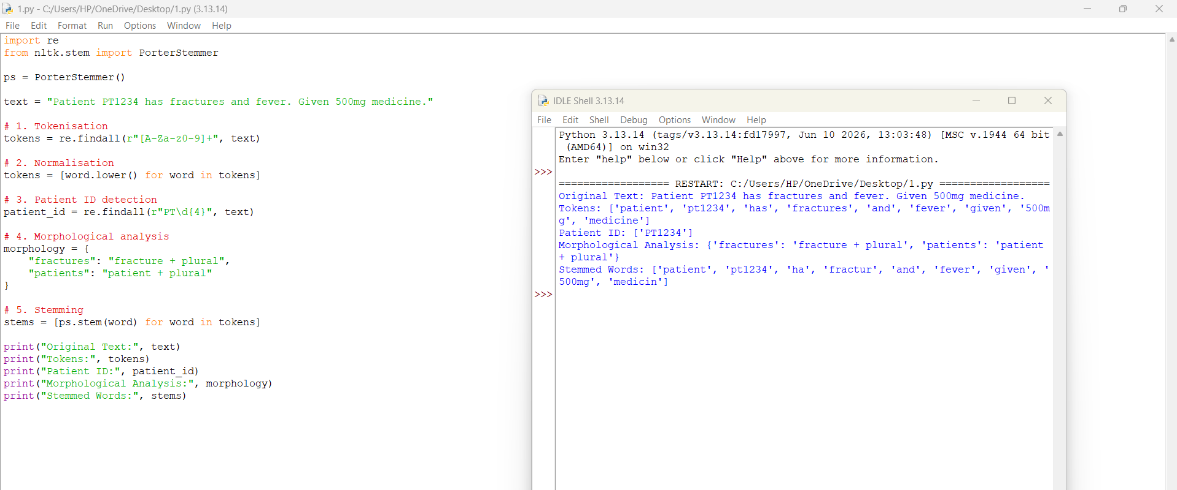
TASK 11 – COMPARE, RECOMMEND AND DEFEND THE NORMALISATION DESIGN
11.1 Comparison of Three Methods
Feature | No Normalisation | Porter Stemmer | Full Morphological Analysis
Accuracy | Low | Medium | High
Recall | Low | Better | High
Processing | Simple | Fast | More complex
Dictionary Required | No | No | Yes
Word Features | Not identified | Not identified | Identified
Maintenance | Low | Low | High
11.2 Recommended Design
The recommended design is a combination of regular expressions, finite-state morphological analysis and Porter stemming as a fallback.
The system should first identify structured information, then normalise the text and perform morphological analysis.
Porter stemming can be used for words that are not present in the lexicon, but its output should not replace the original clinical terms.
11.3 Expected Failure Modes
- Unknown medical words may not be recognised.
- Misspellings may cause incorrect matching.
- Ambiguous abbreviations may have multiple meanings.
- Similar medical words may have different clinical meanings.
11.4 Manual Effort and Maintenance
Activity | Required Effort
Writing regular expressions | Medium
Building the lexicon | High
Creating affix rules | Medium
Annotating word forms | High
Testing automata | Medium
Updating medical terminology | Continuous
A statistical or machine-learning approach becomes useful when the vocabulary and spelling variations become too large for manual rules.
Conclusion: A hybrid finite-state system provides a suitable starting point because it is understandable, explainable and useful for structured clinical text.
TASK 12 – DAY-4 DESIGN CHALLENGE: RE-EVALUATE AND ADAPT THE DESIGN
A. IMPACT ANALYSIS
12.1 Introduction
The original system was designed for clean English clinical records. The new requirement introduces OCR-generated text and Romanised regional language mixed with English.
This creates additional difficulties for the original pipeline.
12.2 New Input Problems
1. OCR Errors
OCR may confuse similar characters.
Examples:
0 and O
1 and l
rn and m
2. Line-Break Errors
A word may be divided across two lines.
Example:
post-
operative
3. Out-of-Lexicon Words
Some words may not be present in the existing dictionary.
4. Regional Language
The system may receive regional language words written using English letters.
Example:
patient ku fever irundhuchu
5. Code-Mixing
English and regional language words may appear in the same sentence.
12.3 Assumptions That No Longer Work
Original Assumption | New Problem
Clean typed input | OCR spelling errors
English-only text | Regional language words
Closed vocabulary | Unknown medical terms
Exact matching | Misspelt and noisy words
Standard word boundaries | Line-break errors
12.4 Effect on System Performance
OCR errors reduce the accuracy of regular-expression patterns.
Unknown words reduce morphological analyser coverage.
Code-mixed words cannot always be processed using English morphological rules.
Therefore, the original system requires modification.
Conclusion: The original pipeline is not sufficient for noisy and mixed-language clinical records.
B. EVALUATION OF THE ORIGINAL DESIGN
12.5 Testing New Records
Record 1 – OCR Input
Patient ID: P1D-AB1234
Temp: 37.5 C
Diagnosis: fractu re
Problems:
- The patient identifier contains a character recognition error.
- The word fracture is divided.
- The exact regular-expression pattern may fail.
Record 2 – Code-Mixed Input
patient ku fever irundhuchu
paracetamol 500mg kuduthen
Problems:
- English words may be recognised.
- Regional words may be outside the English lexicon.
- The original analyser cannot identify their grammatical features.
Record 3 – Combined OCR and Code-Mixed Input
P1D-AB1234
patient ku fev er irundhuchu
paracetamol 5O0mg kuduthen
Problems:
- Patient ID is affected by OCR.
- Fever is divided incorrectly.
- The drug strength contains an O instead of zero.
- Regional words are not recognised.
12.6 Performance Degradation
The following table is an illustrative comparison, not an actual experimental measurement.
Metric | Clean Input | Noisy Input
Pattern Precision | 95% | 75%
Pattern Recall | 93% | 70%
Analyser Coverage | 90% | 65%
Retrieval F1 | 90% | 68%
The noisy input reduces the accuracy of the original system because it depends on exact spellings and known vocabulary.
12.7 Alternative Techniques
Weighted Automata: Assign different costs to possible character matches.
Edit Distance: Measures how many insertions, deletions or replacements are needed to convert one word into another.
Character N-gram Language Identification: Uses groups of characters to identify the possible language of a word.
These methods are useful for handling noisy and mixed-language input.
Conclusion: The original design must be improved to handle OCR errors and code-mixed records.
C. ADAPTATION OR REDESIGN
12.8 Selected Approach: MODIFY
The selected approach is to modify the original system rather than completely replace it.
The original finite-state layer is useful for clean clinical text, but it requires additional processing stages.
12.9 Modified Pipeline
DIAGRAM – IMPROVED NLP PIPELINE
OCR AND TYPED RECORDS
|
v
OCR ERROR CORRECTION
(Edit Distance Rules)
|
v
LINE-BREAK REPAIR
|
v
LANGUAGE IDENTIFICATION
(Character N-Grams)
|
v
TOKENISATION
(Regular Expressions)
|
v
ENTITY RECOGNITION
(Regex + Automata)
|
v
EXTENDED MORPHOLOGICAL
ANALYSER
|
v
REGIONAL LANGUAGE
LEXICON
|
v
SEARCH AND RETRIEVAL
|
v
FINAL RESULTS
12.10 Changes to Each Component
Component | Modification
Regular Expressions | Add support for common OCR variations
Automata | Add alternative paths for known variations
Lexicon | Include regional and additional medical words
Rule Cascade | Add line-break repair and spelling correction
Morphological Analyser | Add regional language forms
Search | Use edit-distance matching for unknown words
12.11 Expected Benefits
- More words can be recognised.
- OCR errors can be corrected more effectively.
- Regional language words can be identified.
- Search results become more complete.
- Unknown words can be handled using fallback methods.
The modified system may require additional processing time and annotation effort. However, it provides better coverage for real-world hospital records.
Conclusion: Modifying the original system provides a practical solution without losing the advantages of finite-state processing.
D. EVIDENCE-BASED DEFENCE
12.12 Final Design Decision
The final decision is to modify the original finite-state pipeline.
The original system works well with clean and structured English clinical records. However, OCR errors, unknown words and regional language inputs reduce its performance.
The improved design combines:
- Regular expressions for structured information.
- Finite-state automata for format validation.
- Morphological transducers for word analysis.
- Edit-distance matching for spelling correction.
- Character n-grams for language identification.
- Extended lexicons for regional language words.
12.13 Advantages
- Handles both clean and noisy records.
- Improves recognition of misspelt words.
- Supports English and regional language mixing.
- Preserves the original finite-state processing system.
- Improves the completeness of hospital record searches.
12.14 Remaining Limitations
Even the modified system has limitations.
- It may not understand every medical abbreviation.
- It may not correctly interpret every regional language expression.
- OCR errors may still produce incorrect text.
- Similar words may have different medical meanings.
- Finite-state systems cannot understand complete clinical context on their own.
12.15 Final Defence
The modified system is selected because it combines the accuracy and explainability of rule-based processing with additional techniques for handling noisy text.
Instead of replacing the original system, the new design extends its capabilities.
This makes it more suitable for a hospital environment where records may contain typed text, scanned documents, spelling errors and mixed-language expressions.

CONCLUSION
The project developed a morphology-aware text normalisation and search design for hospital records using Natural Language Processing techniques.
Regular expressions were used to identify structured clinical information such as patient identifiers, dates, drug strengths and laboratory values. Finite-state automata were used to validate input formats. Inflectional and derivational morphology helped identify relationships between different word forms.Finite-state transducers connected surface words with their stems and grammatical features. The Porter Stemmer provided an additional method for reducing words to root-like forms.
The Python implementation demonstrated the main stages of the pipeline. The Day-4 design challenge showed that the original system needs modification to handle OCR errors, unknown vocabulary and regional language code-mixing.Overall, the project shows that combining regular expressions, finite-state methods and morphological analysis can improve the normalisation and searching of clinical records.

